PRACTICAL NO 2
AIM:- working with aggregate functions, Order by and group by operations

- AGGREGATION CLAUSE
Q1) average and sum for salary of employee where doj is greater than 01/6/2022
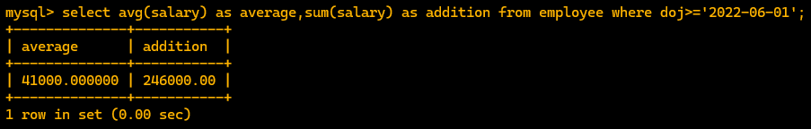
Q2) tell me no of employee whose name starts with a
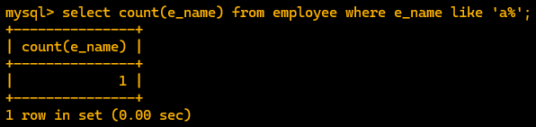
Q3) show the average salary of employee who has joined in 2022
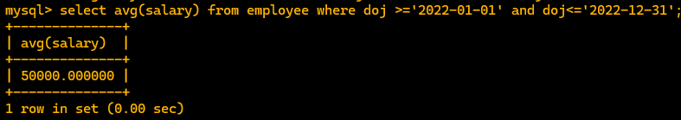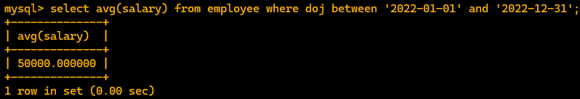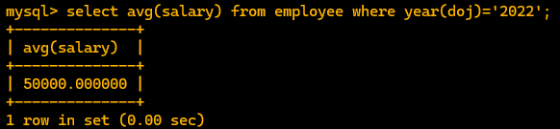
Q4) identify the no of records belongs to no department
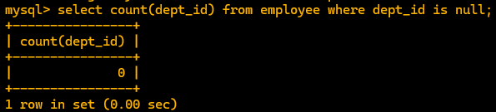
Q5) count the total no of records
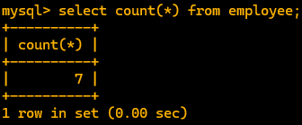

- GROUP BY CLAUSE
Q1) DISPLAY THE NO OF EMPLOYEE WORKING FOR DIFFERENT DESGINATION
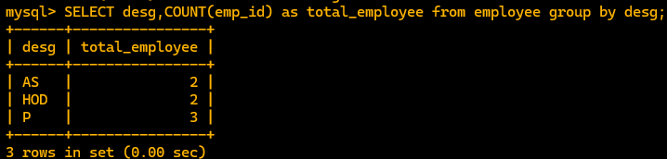
Q2) Display the count of Hod from each dept .
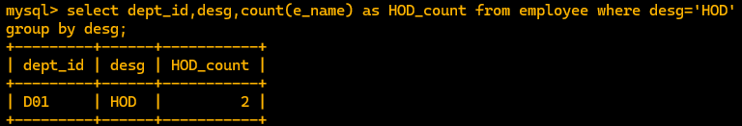
Q3) display avg salary for each designation joined after 2017
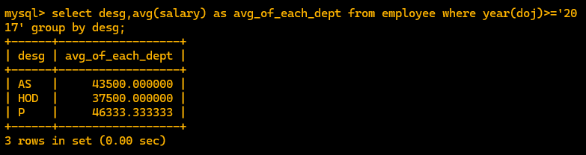
- ORDER BY CLAUSE
Order is sort for ascending and descending it sort the view not the column
Q1) show all the data in order of the doj in ascending order
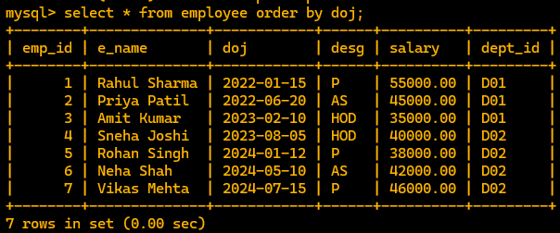
Q2) show all the data from the employee order by department in descending and designation in ascending respectively
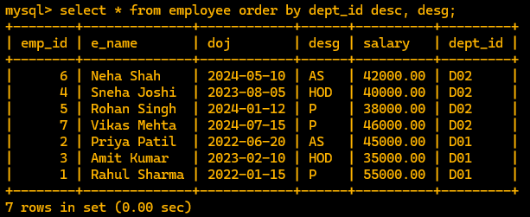

Q3) showing the all data from employee table where there salary is between 30k and 40k and order is dept_id in descending and designation in ascending


